**Menu Table**

* **Create Query:**

**Create table of name MENU with attributes SERIAL_NO (PK), INAME for item names, PRICE for each item’s price and QUANTITY for item’s quantity.**

CREATE TABLE MENU

( SERIAL_NO NUMBER(3) PRIMARY KEY ,

INAME VARCHAR2(15),

PRICE NUMBER(7,2),

QUANTITY VARCHAR2(7));

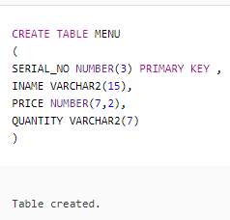

* **Insert Queries:**

INSERT INTO MENU VALUES

(151,'CHICKEN KARAHI',5000, '8 KG');

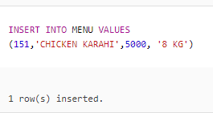

INSERT INTO MENU VALUES

(152,'MUTTON KARAHI',8000, '8 KG');

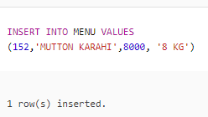

INSERT INTO MENU VALUES

(153,'CHICKEN BIRYANI',7000, '8 KG');

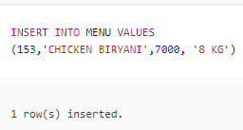

INSERT INTO MENU VALUES

(154,'CHICKEN PULAO',6000, '8 KG');

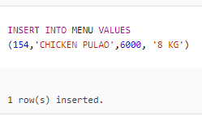

INSERT INTO MENU VALUES

(155,'CHICKEN QORMA',5500, '8 KG');

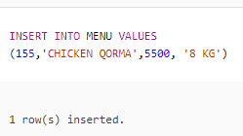

INSERT INTO MENU VALUES

(156,'SALAD',3000, '6 KG');

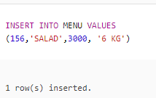

INSERT INTO MENU VALUES

(157,'RAITA',4000, '8 KG');

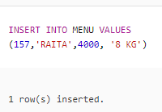

* **Delete Queries:**



**Remove record from MENU where SERIAL_NO is 158.**

DELETE FROM MENU

WHERE SERIAL_NO = 158;

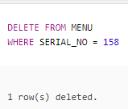



**Remove record from MENU where SERIAL_NO is 159.**

DELETE FROM MENU

WHERE SERIAL_NO = 159;

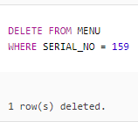



**Remove record from MENU where SERIAL_NO is 160.**

DELETE FROM MENU

WHERE SERIAL_NO = 160;

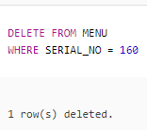



**Remove record from MENU where SERIAL_NO is 161.**

DELETE FROM MENU

WHERE SERIAL_NO = 161;

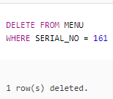



**Remove record from MENU where SERIAL_NO is 162.**

DELETE FROM MENU

WHERE SERIAL_NO = 162;

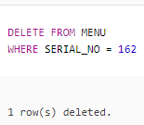

* **Update Queries:**



**Update item name as CHICKEN TIKKA where SERIAL_NO is 156. The Price of 6 KG chicken tikka is 8000.**

UPDATE MENU

SET INAME = 'CHICKEN TIKKA’, PRICE = 8000, QUANTITY = '6 KG'

WHERE SERIAL_NO = 156;

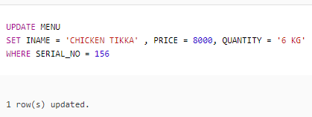

**Update the MENU item as “EGG FRIED RICE” where SERIAL_NO is 154.**

UPDATE MENU

SET INAME = 'EGG FRIED RICE'

WHERE SERIAL_NO = 154;

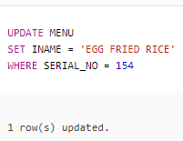



**Change the SERIAL_NO of menu item where SERIAL_NO is 152. New SERIAL_NO is 160.**

UPDATE MENU

SET SERIAL_NO = 160

WHERE SERIAL_NO = 152;

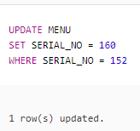



**Change the QUANTITY of item from 8 KG to 10 KG having SERIAL_NO 155.**

UPDATE MENU

SET QUANTITY = '10 KG'

WHERE SERIAL_NO = 155;

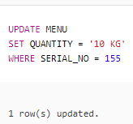



**Update price of item “3600” having SERIAL_NO 157.**

UPDATE MENU

SET PRICE = 3600

WHERE SERIAL_NO = 157;

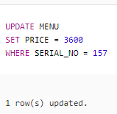

* **Other Queries:**

**Show item name as “ITEM NAME” and serial number as “ID” of menu.**

SELECT INAME “ITEM NAME”, SERIAL_NO “ID”

FROM MENU;

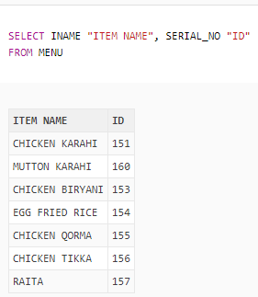

**Show item name and price of all those items of menu whose serial number is greater than 156.**

SELAECT INAME, PRICE

FROM MENU

WHERE SERIAL_NO > 156;

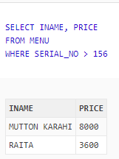

**Display item name of menu of chicken related items.**

SELECT INAME

FROM MENU

WHERE LIKE ‘%CHICKEN%’;

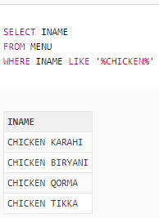

**Show serial number of menu items as “MENU IDENTITY”.**

SELECT SERIAL_NO “MENI IDENTITY”

FROM MENU;

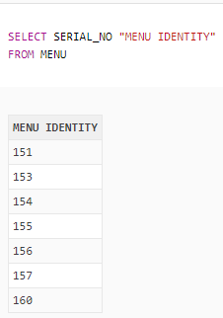

**Give item number, quantity and price of all those items who have A in their names.**

SELECT INAME, QUANTITY, PRICE

FROM MENU

WHERE INAME LIKE ‘%A%’;

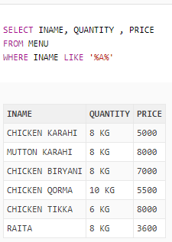

**Show serial number, name, price and quantity of all those items of menu whose id is 155.**

SELECT SERIAL_NO, INAME, PRICE, QUANTITY

FROM MENU

WHERE SERIAL_NO = 155;

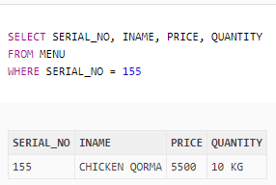

**Show serial number, name, price and quantity of all those items of menu who have quantity greater than 7 KG.**

SELECT SERIAL_NO, INAME, PRICE, QUANTITY

FROM MENU

WHERE QUANTITY > ‘7 KG’;

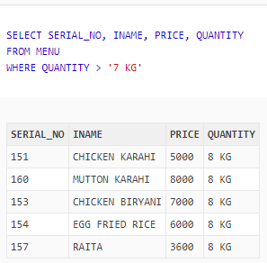

**Show name and price of all those items of menu who have serial number greater than 158 and have R in their names and price is less than 5000 and quantity is 8 KG.**

SELECT INAME, PRICE

FROM MENU

WHERE SERIAL_NO > 158

AND INAME LIKE ‘%R%’

AND PRICE < 5000

AND QUANTITY = ‘8 KG’;

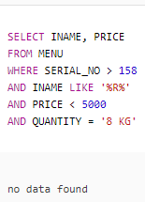

**Give name and price of all those items of menu who have serial number less than 158 and name have R and price is not equal to 5000, 6000 or 8000 and quantity is 8 KG.**

SELECT INAME, PRICE

FROM MENU

WHERE SERIAL_NO ‘%R%’

AND PRICE NOT IN (5000, 6000, 8000)

AND QUANTITY = ‘8 KG’;

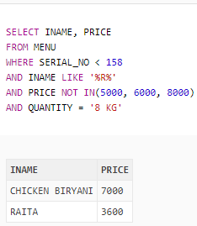

**Give name, quantity and price of all items of menu those haven’t chicken.**

SELECT INAME, QUANTITY, PRICE

FROM MENU

WHERE INAME NO LIKE ‘%CHICKEN%’;

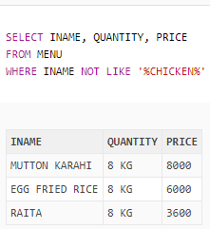

**Display all date of items of menu whose price is greater than 6000.**

SELECT *

FROM MENU

WHERE PRICE > 6000;

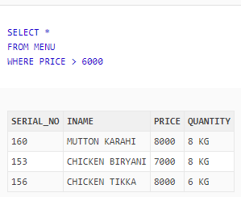

**Give item name, quantity and price of all those items who have price between 6000 and 8000 and quantity is not equal to 6 KG.**

SELECT SERIAL_NO, INAME

FROM MENU

WHERE PRICE BETWEEN 6000 AND 8000

AND QUANTITY <> ‘6 KG’;

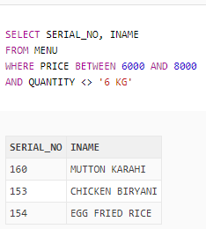

**Show all record of menu for those items whose quantity is greater than 8 KG.**

SELECT *

FROM MENU

WHERE QUANTITY > ‘8 KG’;

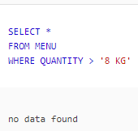

**Give serial number and item name of menu who have price between 6000 and 8000 and quantity is not equal to 6 KG and serial number is 156.**

SELECT SERIAL_NO, INAME

FROM MENU

WHERE PRICE BETWEEN 6000 AND 8000

AND QUANTITY <> ‘6 KG’

AND SERIAL_NO = 156;

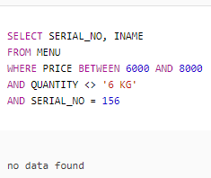

**Give serial number of all those items who is CHICKEN KARAHI or MUTTON KARAHI and price is less than 8000.**

SELECT SERIAL_NO

FROM MENU

WHERE INAME IN (‘CHICKEN KARAHI’, ‘MUTTON KARAHI’)

AND PRICE < 8000;

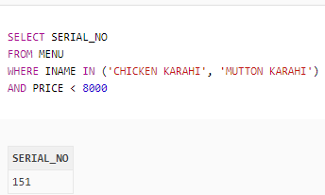

* **Function Queries:**

**Display item names in lower case as “ITEM NAME”, length of item name as “LENGTH OF INAME” and price in term of $ for per 1000.**

SELECT LOWER (INAME) “ITEM NAME”, LENGTH (INAME) “LENGTH OF INAME”,

LPAD (‘ ‘, PRICE/1000 + 1, ‘$’)

FROM MENU;

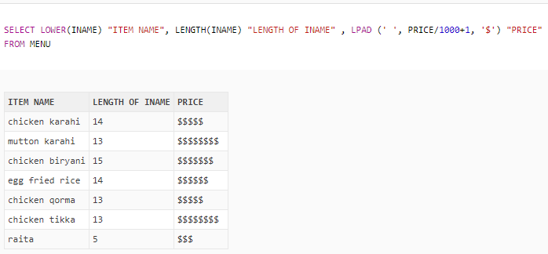

**Show count of item name of all those items who have CHICKEN in their name as “COUNT”.**

SELECT COUNT (INAME) “COUNT”

FROM MENU

WHERE INAME LIKE ‘%CHICKEN%’;

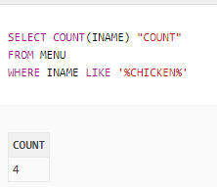

**Give item name and first 3 letters of item name as “FIRST 3 LETTERS”.**

SELECT INAME, SUBSTR (INAME, 1, 3) “FRIST 3 LETTERS”

FROM MENU;

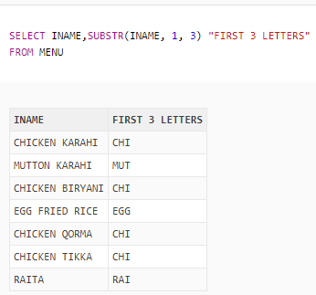

* **Sub-Queries:**

**Display serial number, name and price of all those items of menu whose serial number is less than the serial number of CHICKEN KARAHI.**

SELECT SERIAL_NO, INAME, PRICE

FROM MENU

WHERE SERIAL_NO < (SELECT SERIAL_NO

FROM MENU

WHERE INAME = ‘CHICKEN KARAHI’);

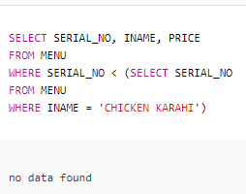

**Show serial number, name, price and quantity of all those items of menu whose price less than the price of those items whose serial number is greater than 155.**

SELECT SERIAL_NO, INAME, PRICE, QUANTITY

FROM MENU

WHERE PRICE < ALL (SELECT PRICE

FROM MENU

WHERE SERIAL_NO > 155) ;

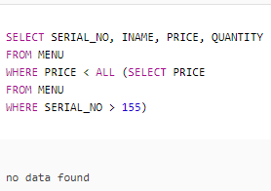

**Display serial number, name, price and quantity of those items of menu whose name is not equal to the name of those items whose price is 3600.**

SELECT SERIAL_NO, INAME, PRICE, QUANTITY

FROM MENU

WHERE INAME <> (SELECT INAME

FROM MENU

WHERE PRICE = 3600);

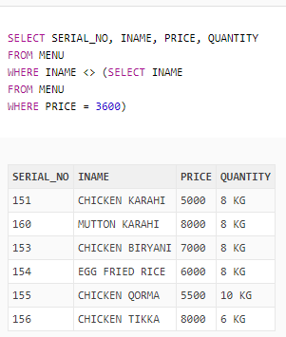

**Table**

